LCC Pico Board Overview
Documentation, source and gerbers for boards may be found at: https://github.com/bocabob/LCC-RPi-Pico-Board

Overview
This board provides a flexible Raspberry Pi Pico (or Pico 2) platform for OpenLCB/LCC nodes. It includes:
- 3.3V and 5V switching power regulation
- Provision for onboard or plug-attached EEPROM or FRAM NVM modules
- Configurable to be powered from LCC, powered independently, or to inject power onto the LCC bus
- Tested with the OpenLCB Single Thread and OpenLcbCLib libraries

Evolution
The LCC Pico development boards evolved from LocoNet designs dating back to 2021. The early turntable boards used Arduino Nanos and depended on turnout commands for indexing to hard-coded stepper positions. Fascia panel input was desired, so a keypad version was developed. This proved cumbersome, so a small touch screen was added with a Mega processor. The screen size needed to grow to nine inches for usability, so the Raspberry Pi Pico was selected. The Pico represents the "Goldilocks" processor of very good function, technical stability, and the easy-to-use Arduino IDE. Moving to the Pico enabled the LCC migration in 2024, when the Single Thread library began to support the RP2040 processor family. With OpenLcbCLib, full protocol support was enabled.
Earlier revisions also included a dedicated Stepper board with its own stepper motor driver circuitry built in. As of v3.0, that circuitry has moved to a separate breakout board that plugs into the standard Node board, so there is no longer a need for a Stepper-specific board design — one Node board now serves every node type.

Families

There is a single board architecture: the Node. It exposes 16 GP pins through two 10P IDC connectors, plus an additional 5-pin analog header (I/O-3), for general-purpose I/O. Specialized functions — stepper motor control, displays, servos, etc. — are added via plug-in breakout boards rather than dedicated board variants.

A variant of the Node is the Lite Node which is slightly smaller and lacks external power inputs and the 3.3 volt power circuitry. 3.3 volt power is supplied by the RPi Pico and is thus limited by that specification and should not exceed about 250mA.

While the boards work with either the Pico or the Pico 2, the Pico 2 is recommended for its enhanced capabilities.

Common Features

Power
The full board provides dual switching power output of 3.3V and 5V with input either from the LCC CAN bus or an external power source between 8 and 15 volts. The boards may be configured to inject power to the CAN bus or to isolate power for either or both of the CAN bus jacks. Auxiliary power outputs for both 3.3V and 5V are available on the board.

CAN Bus Control

Uses the discrete MCP2518 and MCP2562 CAN controller/transceiver hardware (easier to hand-solder than the integrated MCP251863 used on some earlier boards).

Non-Volatile Memory (NVM)
I2C nonvolatile memory is used to reduce strain on the Pico flash. External NVM is soldered down to the IC5 footprint. The I2C Address jumpers may be used to select non-default addresses or implement write protection. Otherwise, these would be functions of the module plugged into the I2C header.
Parts compatible with the following should work for soldering to the footprint on the board.
- BR24G256F-3AGTE2 I2C BUS(2-Wre) 256K or other sizes with equivalent pinouts
- MB85RC256VPF-G-BCERE1 256kbit FRAM with I2C

I2C
One of the two available I2C channels is dedicated to address NVM. The other available I2C channel on the Pico may be configured from appropriate pins on the IDC connections. Care should be taken should you attach peripherals to the same channel as the NVM lest there be interference. Some I2C devices will require 5 volts and so there is selection via jumper between the two available voltages.

Buttons
As there is no reset button on the Pico, one is provided on the board. There is also a header so that a button may be wired in for remote reset. Provision is included for blue and gold buttons; on v3.0 these share pins with the I/O-2 and I/O-3 connectors (see pin table below), so they are unavailable when a breakout uses those specific pins.

IDC Connections
GP pins and other connections are available on 10P IDC connectors (I/O-1, I/O-2), plus a 5-pin analog header (I/O-3). Pinouts are printed on the silkscreen and in the board user guide. On each 10P connector, pin 5 is Ground and pin 6 is a jumper-selectable voltage rail (3.3V or 5V) for the attached breakout.

Board Variants
There are versions with 1206 size components for hand assembly and versions with 0805 sized components for economic production by JLCPCB. All files for assembly input are provided.

LCC-Pico-Node v3.0
- MCP2518 and MCP2562 chips for CAN bus implementation of OpenLCB/LCC protocols
- Two 10-pin IDC connectors (I/O-1, I/O-2) exposing 16 GP pins for general-purpose I/O
- One 5-pin analog header (I/O-3) for additional GP/analog connections
- External power connections for input and/or output to peripheral devices. 5- and 3.3-volt regulation is on board and available from supplied input. Current should not exceed 1 A from each regulated source. External input power is passed through to associated headers.
- Stepper, display, servo, or other specialized functions are added via plug-in breakout boards rather than being built into the Node board itself

LCC-Pico-Node-Lite v3.0
- MCP2518 and MCP2562 chips for CAN bus implementation of OpenLCB/LCC protocols
- Two 10-pin IDC connectors (I/O-1, I/O-2) exposing 16 GP pins for general-purpose I/O
- One 5-pin analog header (I/O-3) for additional GP/analog connections
- LCC bus powered, 5 volt regulated supply, 3.3 volt from Pico (limited capacity)
- Display, servo, or other specialized functions are added via plug-in breakout boards rather than being built into the Node board itself. Current demand should not exceed LCC specifications.

Board Pin Assignments
Pin | GP | Alt 1 | Alt 2 | v3.0 Node
1 | gp0 | SPI0 RX | I2C0 SDA | ACAN_RX_PIN
2 | gp1 | SPI0 CSN | I2C0 SCL | ACAN_CS_PIN
3 | GND
4 | gp2 | SPI0 SCK | I2C1 SDA | ACAN_CSK_PIN
5 | gp3 | SPI0 TX | I2C1 SCL | ACAN_TX_PIN
6 | gp4 | SPI0 RX | I2C0 SDA | ACAN_INT_PIN
7 | gp5 | SPI0 CSn | I2C0 SCL | I/O-2: Pin 10 & Blue Button
8 | GND
9 | gp6 | SPI0 SCK | I2C1 SDA | I2C1 SDA
10 | gp7 | SPI0 TX | I2C1 SCL | I2C1 SCL
11 | gp8 | SPI1 RX | I2C0 SDA | I/O-1: Pin 1
12 | gp9 | SPI1 CSn | I2C0 SCL | I/O-1: Pin 2
13 | GND
14 | gp10 | SPI1 SCK | I2C1 SDA | I/O-1: Pin 3
15 | gp11 | SPI1 TX | I2C1 SCL | I/O-1: Pin 4
16 | gp12 | SPI1 RX | I2C0 SDA | I/O-1: Pin 7
17 | gp13 | SPI1 CSn | I2C0 SCL | I/O-1: Pin 8
18 | GND
19 | gp14 | SPI1 SCK | I2C1 SDA | I/O-1: Pin 9
20 | gp15 | SPI1 TX | I2C1 SCL | I/O-1: Pin 10
21 | gp16 | SPI0 RX | I2C0 SDA | I/O-2: Pin 1
22 | gp17 | SPI0 CSn | I2C0 SCL | I/O-2: Pin 2
23 | GND
24 | gp18 | SPI0 SCK | I2C1 SDA | I/O-2: Pin 3
25 | gp19 | SPI0 TX | I2C1 SCL | I/O-2: Pin 4
26 | gp20 |  | I2C0 SDA | I/O-2: Pin 7
27 | gp21 |  | I2C0 SCL | I/O-2: Pin 8
28 | GND
29 | gp22 |  |  | I/O-2: Pin 9
30 | RUN |  |  | Reset Button / header
31 | gp26 | ADC0 | I2C1 SDA | I/O-3: Pin 1
32 | gp27 | ADC1 | I2C1 SCL | I/O-3: Pin 2
33 | GND | A GND |  | I/O-3: Pin 3 (AGND)
34 | gp28 | ADC2 |  | I/O-3: Pin 5 & Gold Button
35 |  | ADC_VREF |  | I/O-3: Pin 4 (VREF)
36 | 3v3_OUT
37 | 3V3_EN
38 | GND
39 | VSYS
40 | VBUS
 | GND |  |  | I/O-1: Pin 5
 | Vselect1 |  |  | I/O-1: Pin 6
 | GND |  |  | I/O-2: Pin 5
 | Vselect2 |  |  | I/O-2: Pin 6
Note: I/O-2 Pin 10 (gp5) and I/O-3 Pin 5 (gp28) double as the Blue and Gold buttons. A breakout that uses either of those pins makes the corresponding button unavailable.

Node 3.0C
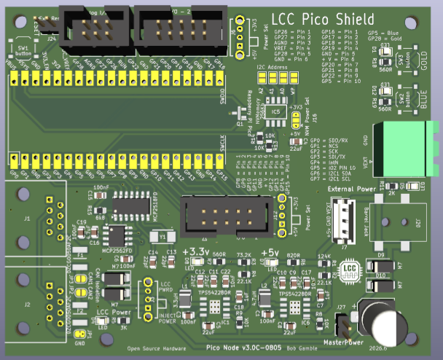
The power circuit uses two separate switching chips which are identical in function and rated for about 1 amp each.
There is a switch to toggle between injecting power to LCC or to be powered from LCC. Each 10 pin IDC connector is associated with a switch to select the voltage (3.3 or 5) passed on the power pin (6) of the connection. There is a solder jumper to select the voltage used for the NVM chip should there be a specific need.

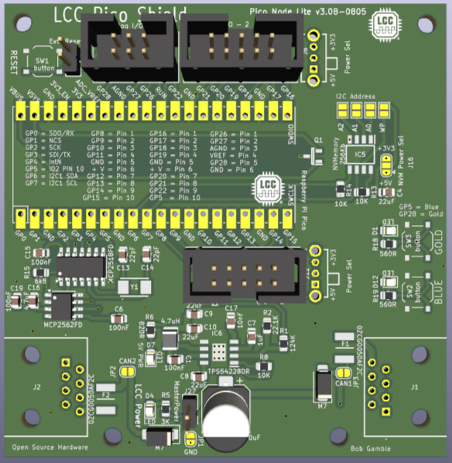
Node Lite 3.0B
There is no provision for external power input. The node draws power from the LCC bus.
This board is built using just a single 5-volt supply and using the Pico 3.3V output pin to power the 3.3V for CAN and NVM circuits. Draw should not exceed 200-250mA.
Other than that, it has essentially the same functionality as Node 3.0C.

IDC Breakout Boards
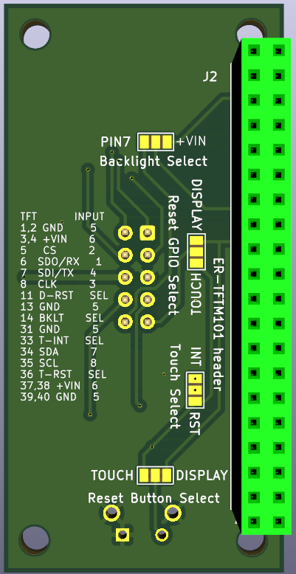
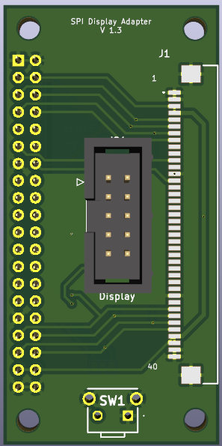
Display 101 Adapter — attaches to a BuyDisplay ER-TFTM101 10.1" touchscreen for SPI display control and I2C touch. Includes provision for alternate assignments of line 10 and a reset button.

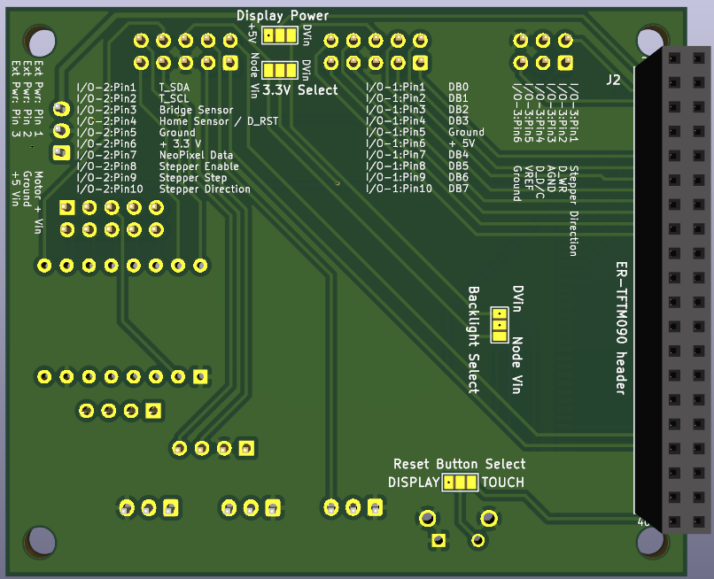
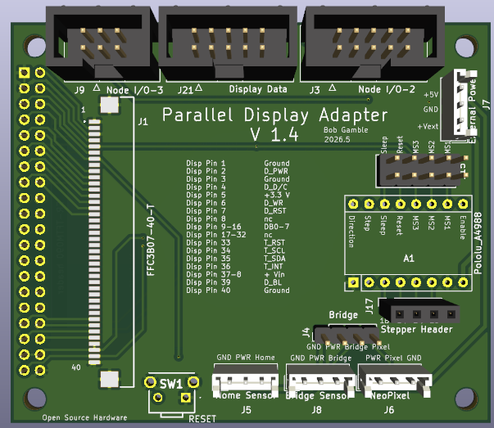
Display 090 Adapter — attaches to a BuyDisplay ER-TFTM090 9.0" touchscreen for parallel display control and I2C touch. Includes provision for alternate assignments of line 10 and a reset button.

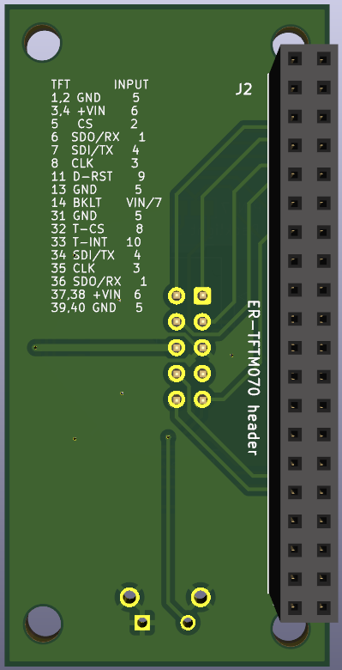
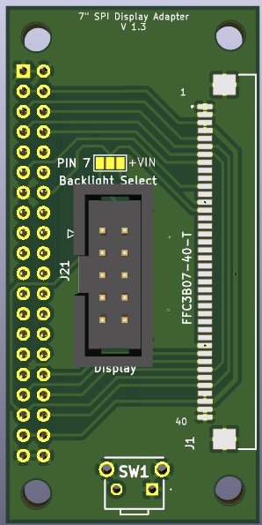
Display 070 Adapter — attaches to a BuyDisplay ER-TFTM070 7.0" touchscreen for SPI display and touch control. Includes provision for alternate assignments of line 10 and a reset button.

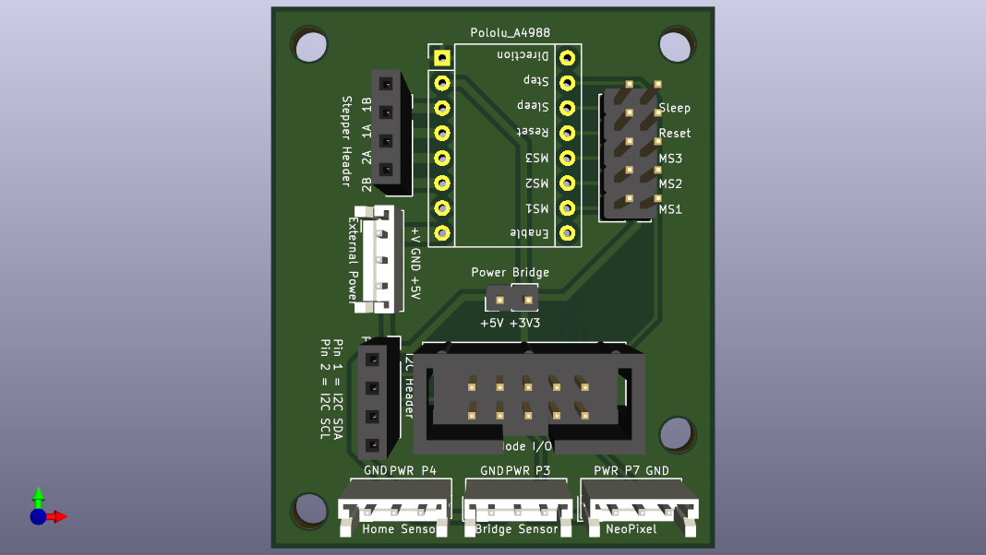
Stepper Breakout — carries a stepper motor driver and provides connections to the stepper motor, sensors, NeoPixel bus, and an I2C connection. Has a separate power connection for the external stepper motor supply (12–15V) and for the +5V used for Hall sensors and the NeoPixel bus; the IDC connector voltage should be set to 3.3V on the Node side when this breakout is attached.

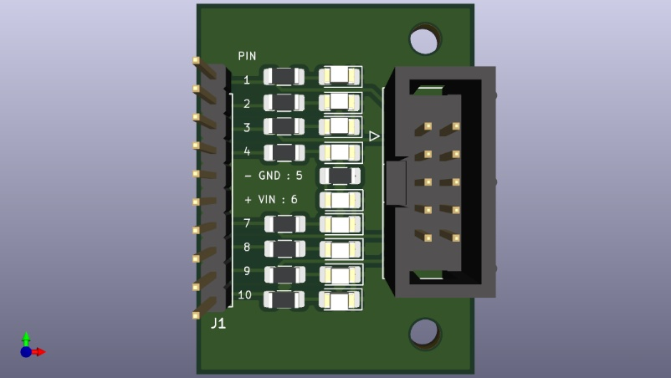
Ribbon Breakout — IDC breakout with optional LEDs for testing.

Servo Breakout — IDC breakout with power and ground pins around each GPIO pin to facilitate connections to inputs, servos, NeoPixels, or other devices.
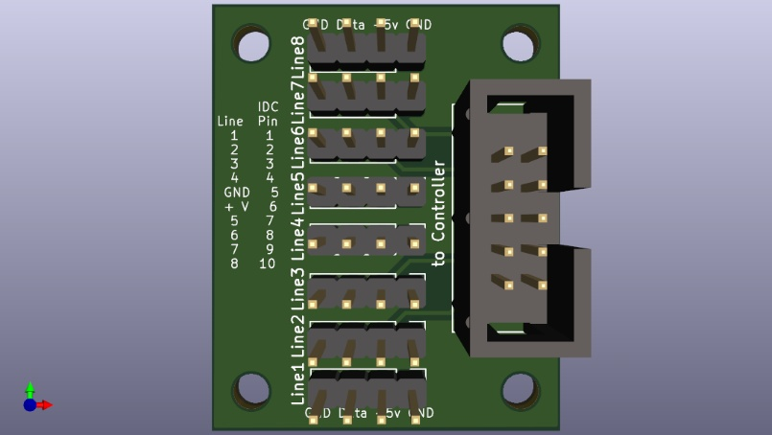

Software

Example Node Applications
- https://github.com/bocabob/LCC_RPiPico_Turntable
- https://github.com/bocabob/LCC_RPiPico_Roundhouse
- https://github.com/bocabob/LCC_RPiPico_PixelLights
- https://github.com/bocabob/LCC_RPiPico_Clock_Lights

Architectural Standard
Cross-project firmware conventions (board versioning, breakout pin assignments, configuration memory, naming) for all node applications above are documented in: https://github.com/bocabob/LCC_RPiPico_Common

Board Support
Use the RP2040 board library by Earle Philhower: https://arduino-pico.readthedocs.io/en/latest/install.html

LCC Support
- https://github.com/openlcb/OpenLCB_Single_Thread
- https://github.com/JimKueneman/OpenLcbCLib

CAN Hardware
- ACAN2517 Arduino library

External Storage
- I2C_EEPROM Arduino library by Rob Tillaart
- FRAM_I2C Arduino library by Rob Tillaart

NeoPixel
- NeoPixelBus by Makuna (preferred)
- NeoPixelConnect by Alan Yorinks

Other Preferred Libraries

Display
- TFT_eSPI_RA8876.h — display library (modified): https://github.com/bocabob/TFT_eSPI_RA8876
- RA8876_RP2040.h — display library (modified): https://github.com/bocabob/RA8876_RP2040
- my_bb_captouch.h — capacitive touch driver (modified): https://github.com/bocabob/my_bb_captouch

Servos
- ServoEasing.hpp — for slow servo action, including bounces
- PCA9685_servo_driver.h
- PCA9685_servo.h

Stepper Motor
- AccelStepper.h by Mike McCauley (modified)

